. Open your command prompt by typing cmd in your run. **Start ⇒ Run ⇒ type cmd**.

c:\<path-to-jdk-dir>\bin\keytool.exe -list -alias androiddebugkey -keystore "C:\users\<user-name>\.android\debug.keystore" -storepass android -keypass android

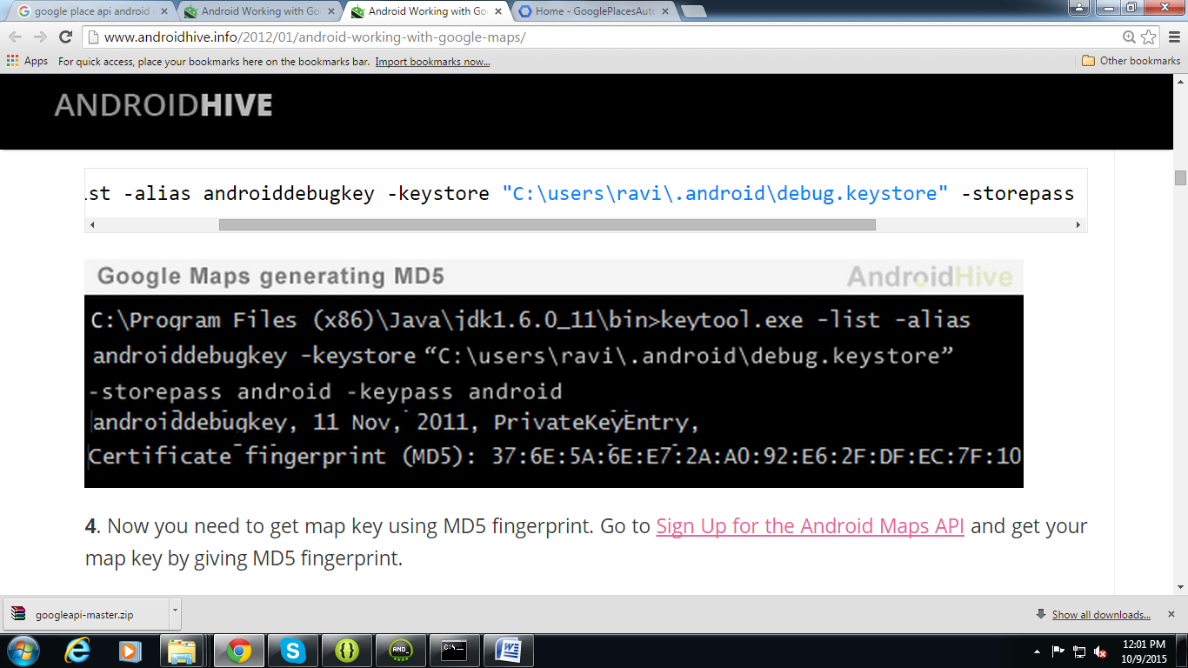

Alternate way:

Go to Eclipse>Windows>Preferences>Android>Build>SHA1

Go to https://console.developers.google.com

Create Project>APIs & auth>Crdentials>Add Credentials>Api Key>ServerKey (it will run on both,browser and android) and create Server Key

* APIs & auth>APIs >Enable Google Maps APIs **-** [Google Places API Web Service](https://console.developers.google.com/project/tidal-nova-109213/apiui/apiview/places_backend/overview), [Google Places API for Android](https://console.developers.google.com/project/tidal-nova-109213/apiui/apiview/placesandroid/overview)